TESTING PROCESS

**Qui Ngo**

**Version 1.1**

**Revision History**

|  |  |  |  |  |  |
| --- | --- | --- | --- | --- | --- |
| **Version** | **Date** | **Author** | **Editor** | **Content** | **Status** |
| 1.0 | 16/05/2016 | Qui Ngo |  | Create Testing Process document | Done |
| 1.1 | 30/06/2017 | Qui Ngo | Qui Ngo | Update :   * 2. Testing Process * 2.3 Testing Description   Add:   * 2.1 Role and Responsibility * 3 Document Deliverables * 5. Test Environment | Done |

**Table of Contents**

**1.** **Introduction** 4

**1.1.** **Purpose** 4

**1.2.** **Intended audience** 4

**2.** **Testing Process** 4

**2.1.** **Roles and Responsibility** 4

**2.2.** **Testing process activity** 5

**2.3.** **Testing description** 5

**3.** **Documents Deleverables** 7

**5.** **Test Environment** 7

**5.1**  **Hardware** 7

**5.2**  **Software** 7

**6.** **References** 7

**List of Figure**

**Figure 1 Testing process** 5

**List of Table**

**Table 1. Intended audience** 4

**Table 2 . Role and Responsibility** 4

**Table 3. Testing Description** 6

**Table 4. Document Deliverables** 7

**Table 5. Measurement** 7

**Table 6. Hardware** 7

**Table 7. Software** 7

# **Introduction**

## **Purpose**

Testing is a process rather than a single activity. This process starts from test planning then designing test cases, preparing for execution and evaluating status till the test closure.

## **Intended audience**

|  |  |  |
| --- | --- | --- |
| **Role** | **Name** | **Responsibility** |
| Test Leader | Qui Ngo | Develop Test Plan, Test Case and Monitoring in Tet Phase |
| Project Manager | Van Phan | Monitoring and Control Schedule |
| Tester | Nhuan Tran,Tan Huynh, Thang Nguyen | Develop Test Case, Execution Test Case and Develop Test Report. Communication with Develop Team |

**Table 1. Intended audience**

# **Testing Process**

## **Roles and Responsibility**

|  |  |  |
| --- | --- | --- |
| No | Vai Trò | Trách Nhiệm |
| 1 | Test Leader | Responsible for guidance, plan and track the progress of the work of the test group, Write test summary report and update schedule in Test phase, overview report test case and reports directly to the PM. |
| 2 | Tester | Read document to know Test plan and follow it to work in Test phase. Responsible execute testing system following testing documents and reports bugs to Test Leader directly. |
| 3 | Customer | Responsible perform User Acceptance test for the release of system. |

**Table 2 . Role and Responsibility**

## **Testing process activity**

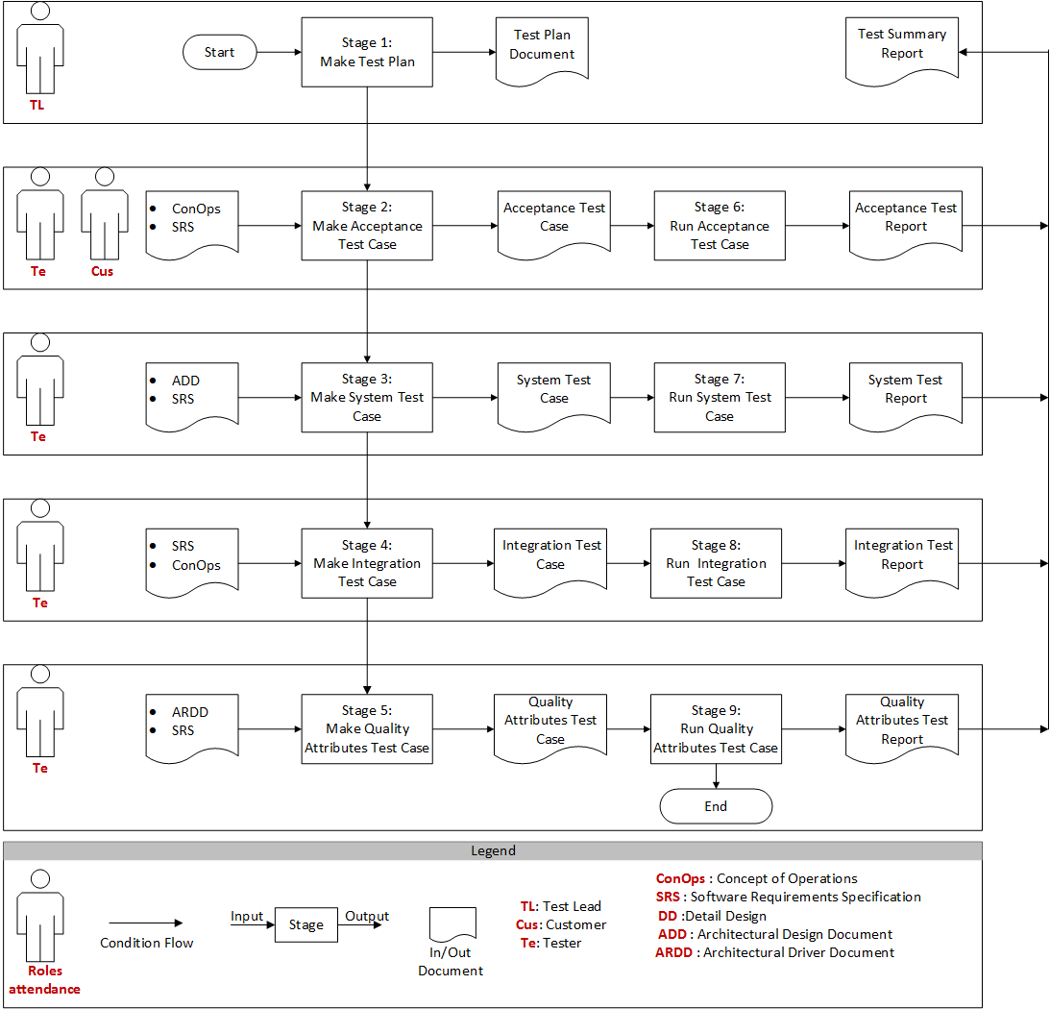

**Figure 1 Testing process**

## **Testing description**

|  |  |  |  |  |
| --- | --- | --- | --- | --- |
| Stages | Description | Input | Output | Role |
| Make test plan | Develop test plan document to perform testing phase:   * Assign work * Schedule |  | Test Plan | Test Leader |
| Make Acceptance Test Case | Test leader assigns tasks to tester for develop acceptance test case based on SRS and ConOps document | ConOps  SRS | Acceptance Test Case | Tester |
| Make System Test Case | Test leader assigns tasks to tester for develop acceptance test case based on ADD and SRS document | ADD  SRS | System Test Case | Tester |
| Make Integration Test Case | Test leader assigns tasks to tester for develop acceptance test case based on DD and ADD document | DD  ADD | Integration Test Case | Tester |
| Make Quality Attributes Test Case | Test leader assigns tasks to tester for develop acceptance test case based on ARDD, SRS and ConOps document. | ARDD  SRS  ConOps | Quality Attributes Test Case | Tester |
| Run Acceptance Test Case | After make acceptance test cases, test leader assign tasks to tester to execute acceptance test cases  Perform Acceptance Test from the test case document them into Test report document. | Acceptance Test Case | Acceptance Test Report | Tester and Customer |
| Run System Test Case | After make system test cases, test leader assign tasks to tester to execute system test cases  Perform System Test from the test case document them into Test report document. | System Test Case | System Test Report | Tester |
| Run Integration Test Case | After make integration test cases, test leader assign tasks to tester to execute integration test cases  Perform Integration Test from the test case document them into Test report document. | Integration Test case | Integration Test Report | Tester |
| Run Quality Attributes Test Case | After make quality attributes test cases, test leader assign tasks to tester to execute quality attributes test cases  Perform Quality Attributes Test from the test case document them into Test report document. | Quality Attributes Test Case | Quality Attributes Test Report | Tester |

**Table 3. Testing Description**

# **Documents Deleverables**

|  |  |
| --- | --- |
| No. | Document |
| 1 | ECB_TE_AcceptanceTestcase_Ver |
| 2 | ECB_TE _SystemTestcase_Ver |
| 3 | ECB_TE _Integration Test_Ver |
| 4 | ECB_TE _QualityAttributeTestcase_Ver |
| 5 | ECB_TE _TestSummary_Ver |

**Table 4. Document Deliverables**

1. **Measurement**

|  |  |  |  |  |
| --- | --- | --- | --- | --- |
| Goal | Question | Metric | Source | Responsibility |
| Productivity of tester | How long a tester make a test case | Time/ Test Case | Member Time Log | Test Leader |
| How long a tester test a function | Time/ Test Case |

**Table 5. Measurement**

1. **Test Environment**

**5.1 Hardware**

|  |  |  |
| --- | --- | --- |
| No. | Description | Configuration |
| 1 | Main server |  |
| 2 | Work station. |  |

**Table 6. Hardware**

**5.2 Software**

|  |  |  |
| --- | --- | --- |
| No. | Description | Configuration |
| 1 | Main Server | * CentOS 6.4 * Php 5.6.9 * Apache 2.2 |
| 2 | Work station | * Microsoft Office Excel 2010 & 2013 * Operating System 7, 8, 8.1. * Github |

**Table 7. Software**

# **References**

**http://istqbexamcertification.com/what-is-fundamental-test-process-in-software-testing/**